* The testing code default of App.test.js
  + 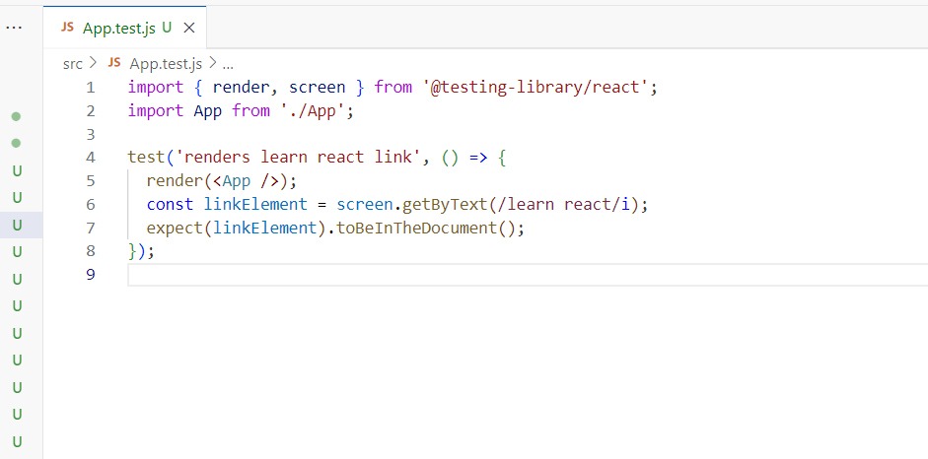
  + With the test function we will execute the test.
  + “render”: It will render the component App.jsx
  + “getByText”: After the component is render by render, we will find the “learn react” text in the getByText() function.
  + expect() function will say whether the text exist in the document.